**Practical No. 14**

**Aim:** Programs development using creation of procedures, passing parameters IN and OUT of PROCEDURES

**Theory:**

Procedures are essential for creating modular and reusable code. They encapsulate a series of statements into a single unit, which can be called and executed independently. Procedures often take parameters, both as inputs (IN) and outputs (OUT), to allow data to be passed in and out of the procedure.

**Queries:**

1) Create one Stored Procedure to Insert, Delete and Update into one table.

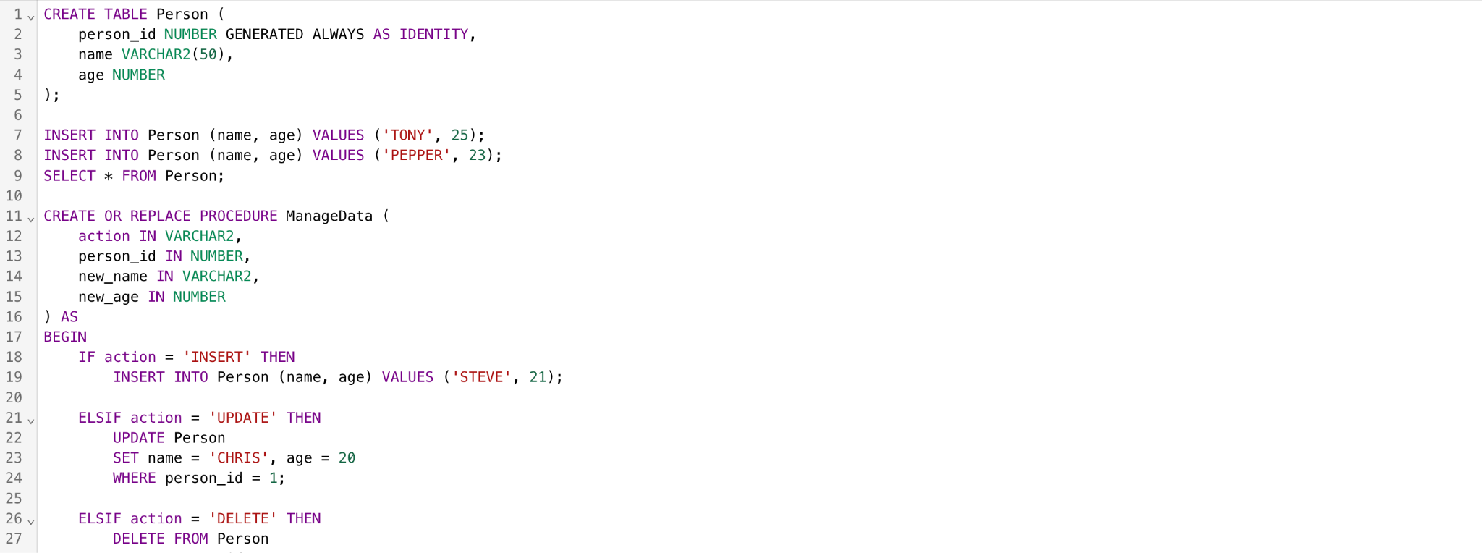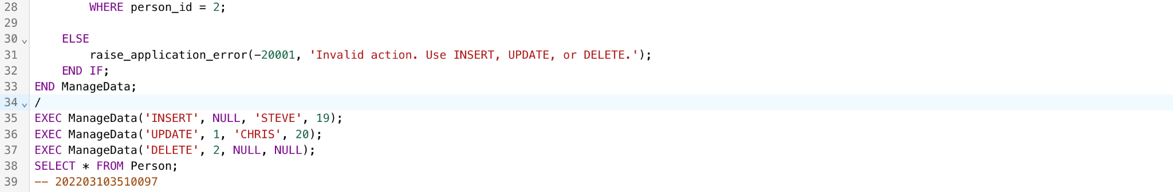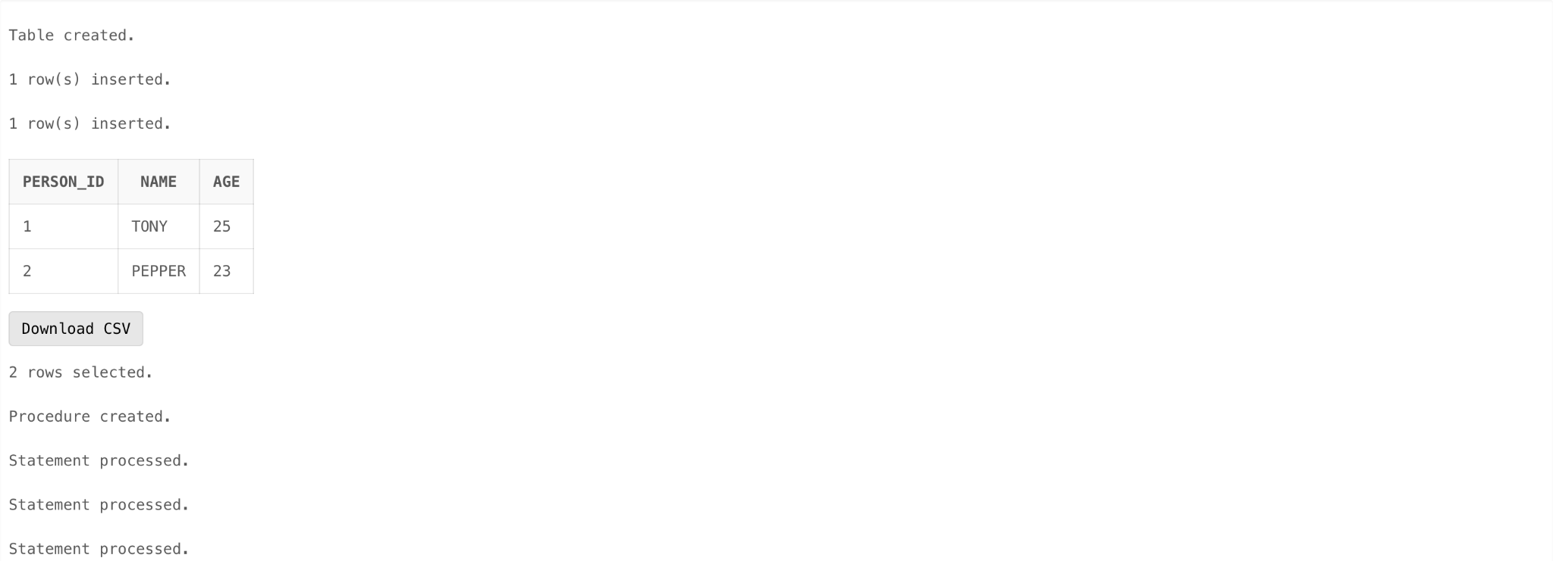

2) Create one Stored Procedure to increment salary with salary range limit.

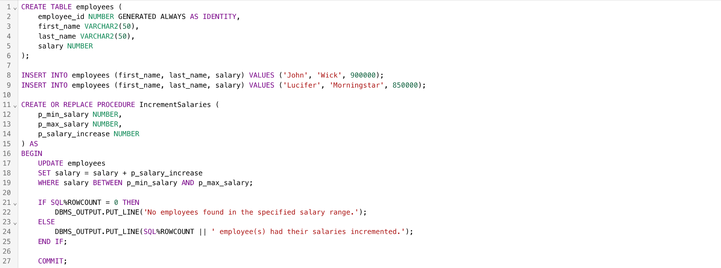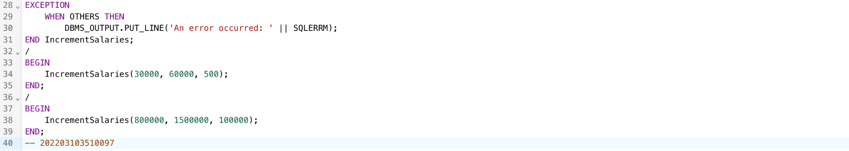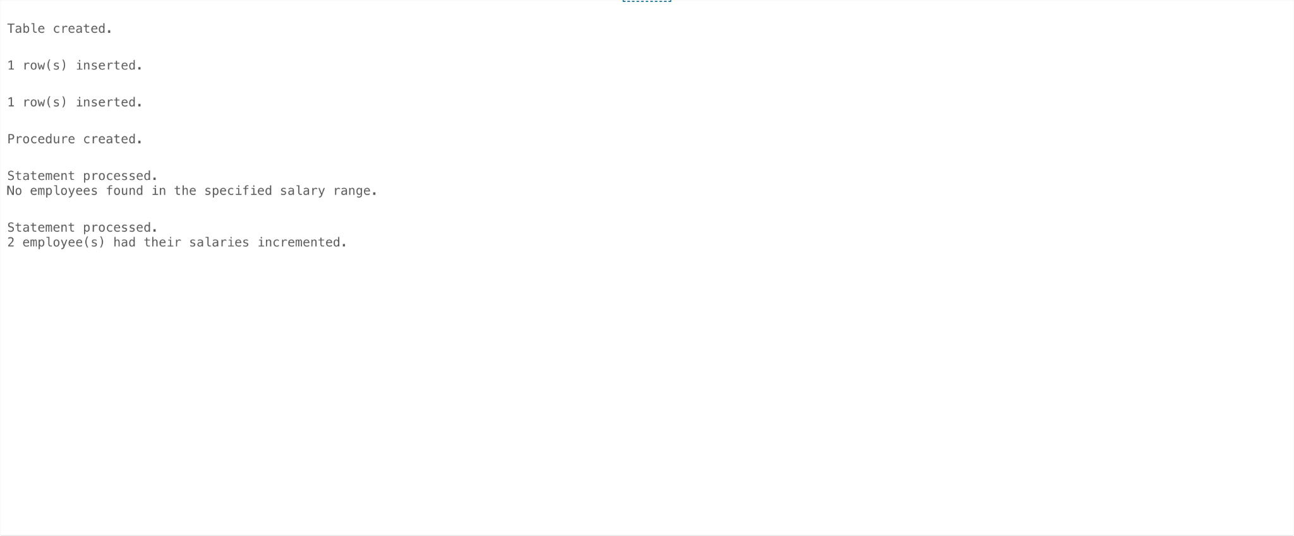

3) Create one Stored Procedure to find largest price with that product name.

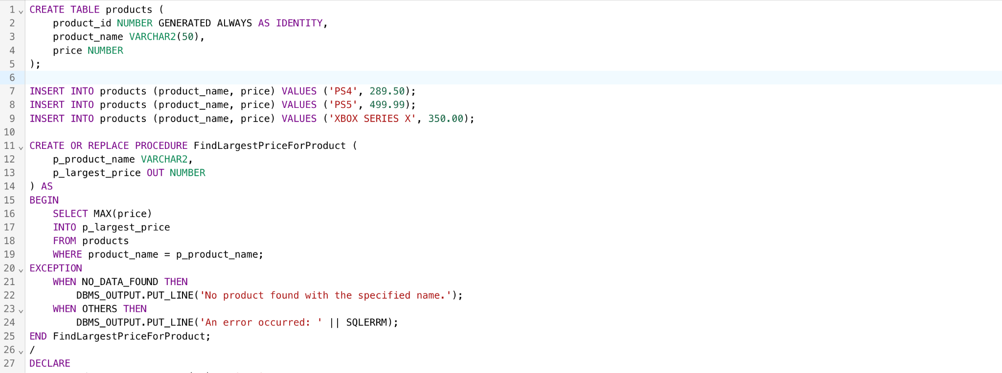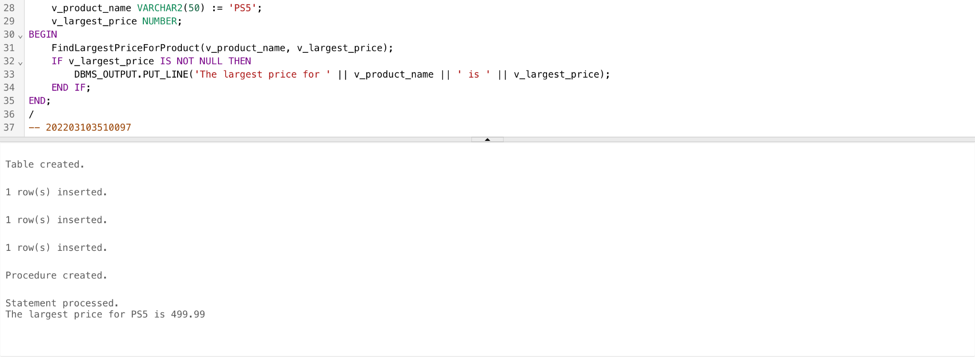

**Conclusion:** The use of procedures with IN and OUT parameters is a fundamental practice in program development, allowing for modularity, code reusability, and improved maintainability. These procedures are widely used in database systems and general-purpose programming to encapsulate and execute specific tasks. Proper parameter design and documentation are key factors in creating effective procedures.